Working with Dates and Timestamps:
current_date, current_timestamp:
To get current date and datetime.
Example:
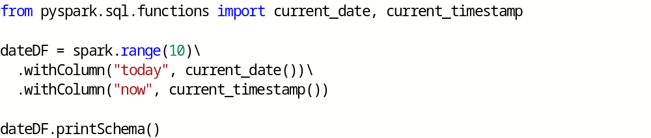
to_date, to_timestamp:
To convert strings to date and timestamp respectively.
Example:
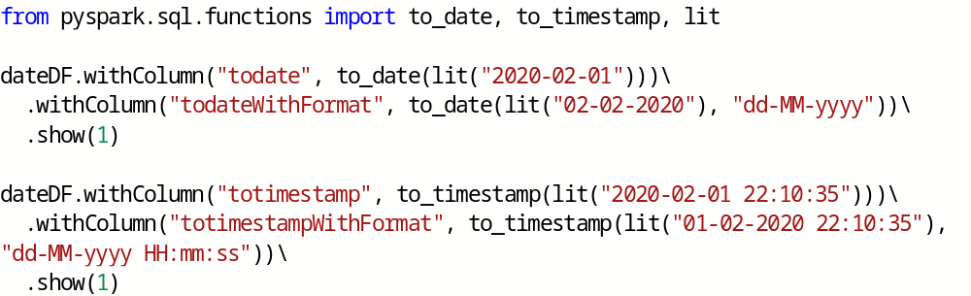
date_add, date_sub:
To add/subtract days from a date column.
Example:

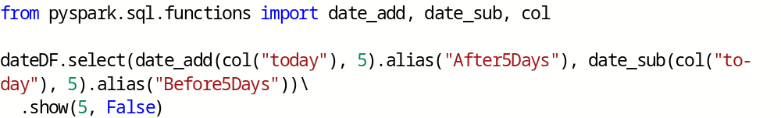
datediff, months_between:
datediff - Gives number of days between two dates.
months_between - Gives number of months between two dates.
Example:
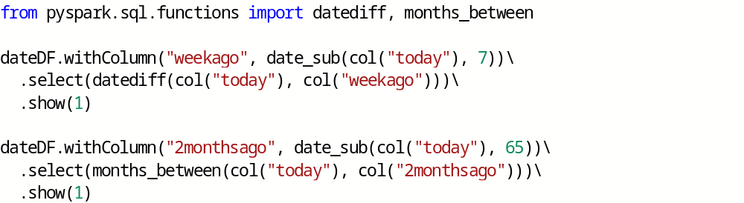
Working with Complex Types:
There are three kinds of complex types: structs, arrays, and maps.
Structs:
We can think of structs as DataFrames within DataFrames.
Example: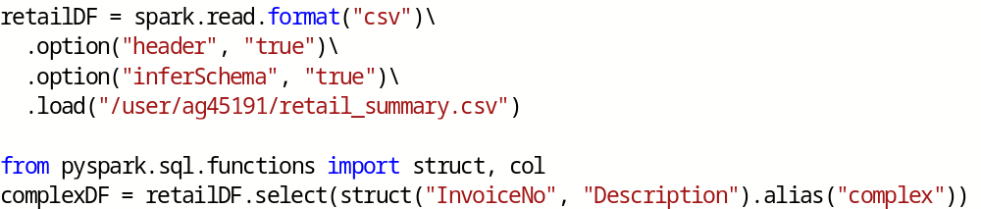

There is a complex column in complexDF. We can use dot notation to access nested columns.

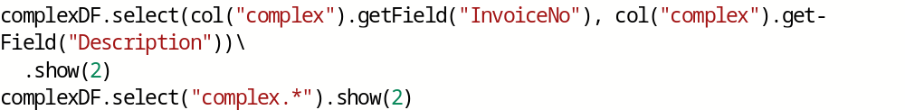

Arrays:
We can create columns with array type and can access and perform operations like below:
Example:

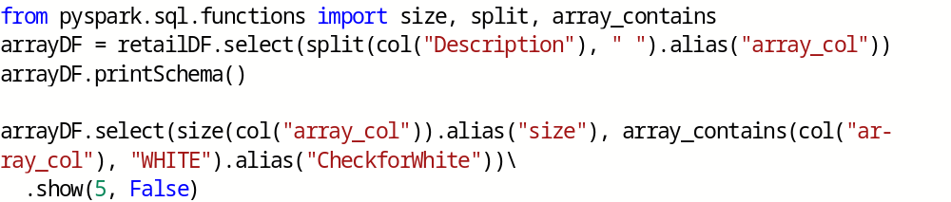
explode():
explode function takes a column that consists of arrays and creates one row (with the rest of the values duplicated) per value in the array.
Example:

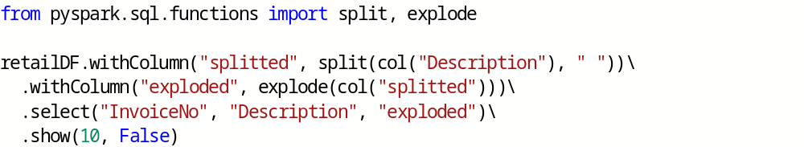
Maps:
Maps are created by using the map function and key-value pairs of columns. You then can select them just like you might select from an array:
Example:

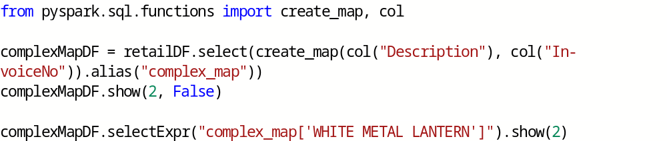
You can also explode map types, which will turn them into columns:
Example:

Working with JSON:
You can operate directly on strings of JSON in Spark and parse from JSON or extract JSON objects.
Example:

get_json_object:
Get JSON object from a JSON string.
Example:

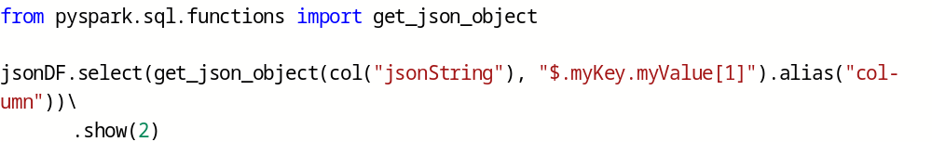
json_tuple:
Use this function to get JSON object if object has only one level of nesting.
Example:

to_json:
Converts a StructType into a JSON string.
Example:
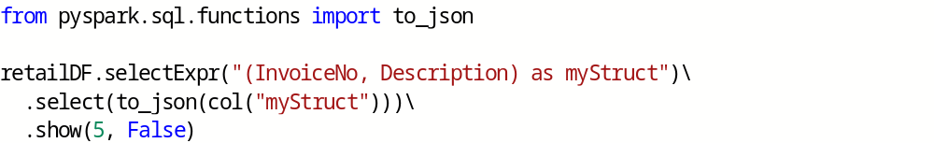

from_json:
Converts JSON string to StructType.
Example:

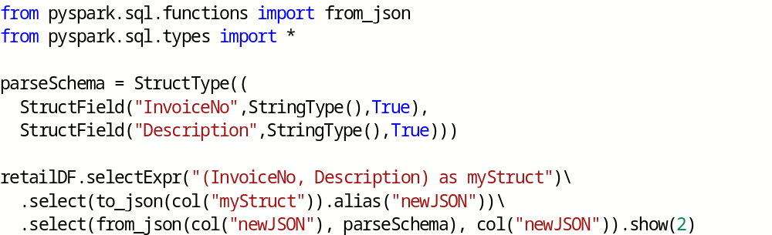

User-Defined Functions:
- UDFs make it possible for you to write your own custom transformations using Python or Scala and even use external libraries.
- UDFs can take and return one or more columns as input.
- By default, these functions are registered as temporary functions to be used in that specific SparkSession or Context.

Steps to create UDFs:
- Create your own function
- Register the function as UDF.

Example:

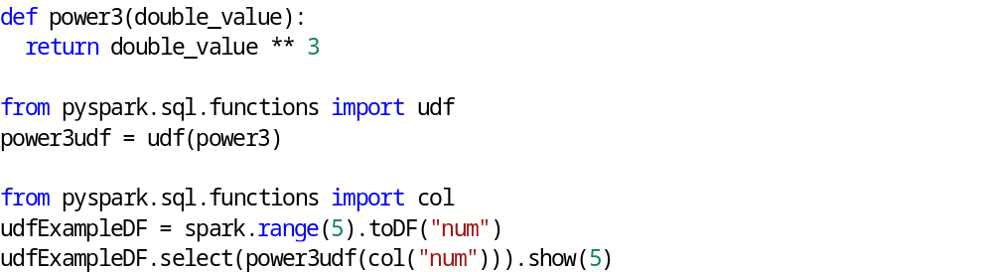

At this juncture, we can use this only as a DataFrame function and we can't use it within a string expression.

However, we can also register this UDF as a Spark SQL function.
Example:

